Intergrade Maven with Jenkins:

1. Setup maven on Jenkins’s server
2. Setup environment variables

JAVA_HOME, M2, M2_HOME

1. Install Maven plugin
2. Configure maven and java

Steps in server: we

1. Cd /opt
2. Wget <https://dlcdn.apache.org/maven/maven-3/3.8.6/binaries/apache-maven-3.8.6-bin.tar.gz>
3. tar -xvzf apache-maven-3.8.6-bin.tar.gz
4. mv apache-maven-3.8.6 maven
5. we have to set environment variable
6. vi /root/.profile
7. 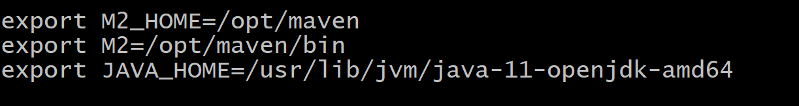

Console:

Global tool: 